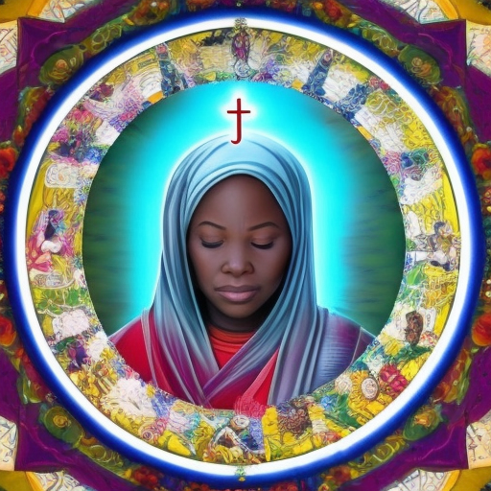

I pray for Joy. I pray that Truth can be the aspirational bond of all Human Beings. I pray that we visit one another in our minds, in our hearts and in our souls. I pray that Wisdom will become everyone's True Mother. I pray that our lights would burn our hearts to heal all misdirection. I pray that we will not be defeated by astonishment at the illusion we leave behind.

